
Abstract Template for MS Word Submissions

How to use this Form

You have chosen to submit your abstract by using an MS Word template. Please write the abstract title as well as the abstract text between the start and end tags, e.g. |Start Title|. With regard to the title, we have preliminary placed your entry from the online submission dialogue. Please feel free to modify this information. Authors and affiliations will be taken from the online submission dialogue and are not subject to modification in this form. Thank you very much for your cooperation!

Abstract Title
@START_ABSTRACT@
|Start Title|
OceanSITES format and Ocean Observatory Output harmonisation: past, present and future
|End Title|

Abstract Text

|Start Text|
The Global Ocean Observing System (GOOS) initiative was launched in 1991, and was the first step in creating a global view of ocean observations. In 1999 oceanographers at the OceanObs conference envisioned a ”global system of eulerian observatories” which evolved into the OceanSITES project.
OceanSITES has been generously supported by individual oceanographic institutes and agencies across the globe, as well as by the WMO-IOC Joint Technical Commission for Oceanography and Marine Meteorology (under JCOMMOPS). The project is directed by the needs of research scientists, but has a strong data management component, with an international team developing content standards, metadata specifications, and NetCDF templates for many types of in situ oceanographic data.
The OceanSITES NetCDF format specification is intended as a robust data exchange and archive format specifically for time-series observatory data from the deep ocean. First released in February 2006, it has evolved to build on and extend internationally recognised standards such as the Climate and Forecast (CF) standard, BODC vocabularies, ISO formats and vocabularies, and in version 1.3, released in 2014, ACDD (Attribute Convention for Dataset Discovery). The success of the OceanSITES format has inspired other observational groups, such as autonomous vehicles and ships of opportunity, to also use the format and today it is fulfilling the original concept of providing a coherent set of data from eurerian observatories.
Data in the OceanSITES format is served by 2 Global Data Assembly Centres (GDACs), one at Coriolis, in France, at ftp://ftp.ifremer.fr/ifremer/oceansites/ and one at the US NDBC, at ftp://data.ndbc.noaa.gov/data/oceansites/. These two centres serve over 26,800 OceanSITES format data files from 93 moorings. The use of standardised and controlled features enables the files held at the OceanSITES GDACs to be electronically discoverable and ensures the widest access to the data.
The OceanSITES initiative has always been truly international, and in Europe the first project to include OceanSITES as part of its outputs was ANIMATE(2002-2005), where 3 moorings and 5 partners shared equipment, methods and analysis effort and produced their final outputs in OceanSITES format. Subsequent European projects, MERSEA(2004-2008) and EuroSITES (2008-2011) built on that early success and the current European project FixO³ encompasses 23 moorings and 29 partners, all of whom are committed to producing data in OceanSITES format.
The global OceanSITES partnership continues to grow; in 2014 the Australian Integrated Marine Observing System ( IMOS) started delivering data to the OceanSITES FTP, and files and India, South Korea and Japan are also active members of the OceanSITES community. As illustrated in figure 1 the OceanSITES sites cover the entire globe, and the format has now matured enough to be taken up by other user groups.
GO-SHIP, a global, ship-based hydrographic program, shares technical management with OceanSITES through JCOMMOPS, and has its roots in WOCE Hydrography. This program complements OceanSITES and directly contributes to the mooring data holdings by providing repeated CTD and bottle profiles at specific locations. GO-SHIP hydrographic data adds a source of timeseries profiles and are provided in the OceanSITES file structure to facilitate full data interoperability.
GO-SHIP has worked closely with the OceanSITES program, and this interaction has produced an unexpected side benefit - all data in the GO-SHIP database will be offered the robust and CF-compliant OceanSITES format beginning in 2015.
The MyOcean European ocean monitoring and forecasting project has been in existence since 2009, and has successfully used the OceanSITES format as a unifying paradigm. MyOcean daily receives hundreds of data files from across Europe, and distributes the data from drifter buoys, moorings and tide gauges in OceanSITES format. These in-situ data are essential for both model verification points and for assimilation into the models.
The use of the OceanSITES format now exceeds the hopes and expectations of the original OceanObs vision in 1999 and the stewardship of the format development, extension and documentation is in the expert care of the international OceanSITES Data Management Team.

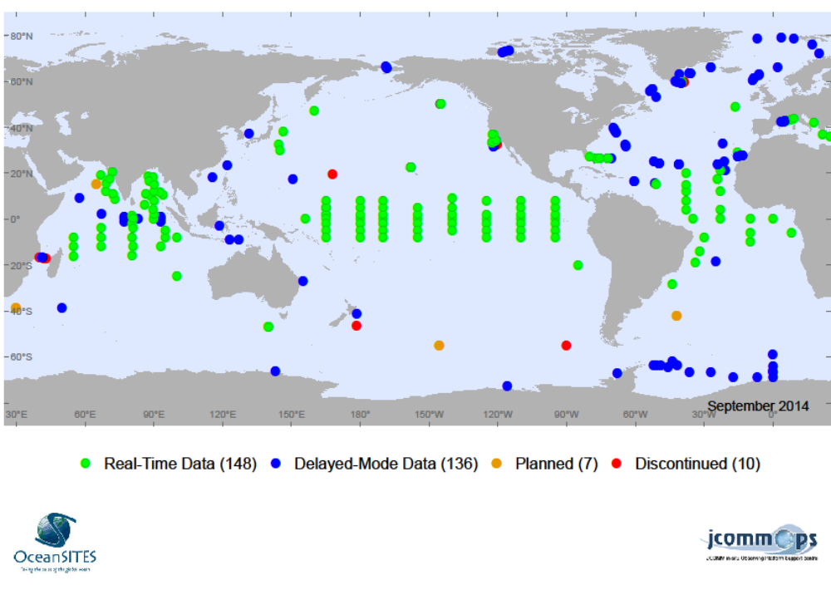
Figure 1
|End Text|
@END_ABSTRACT@

